Data Structure and Algorithm

Laboratory Activity No. 3

Translating Algorithm to Program

|  |  |
| --- | --- |
| *Submitted by:* | *Instructor:* |
| Nerio, Hannah Grace A. | Engr. Maria Rizette H. Sayo |

August, 02, 2025

# Objectives

Introduction

Data structure is a systematic way of organizing and accessing data, and an algorithm is a step-by-step procedure for performing some tasks in a finite amount of time. These concepts are central to computing, but to be able to classify some data structures and algorithms as “good,” we must have precise ways of analyzing them.

This laboratory activity aims to implement the principles and techniques in:

* Writing a well-structured procedure in programming
* Writing algorithm that best suits to solve computing problems
* Writing an efficient Python program from translated algorithms

# Methods

• Design an algorithm and the corresponding flowchart (Note: You may use LucidChart or any application) for adding the test scores as given below if the number is even: 26,49,98,87,62,75

• Translate the algorithm to a Python program (using Google Colab)

• Save your source codes to GitHub

# Results

• Design an algorithm and the corresponding flowchart (Note: You may use LucidChart or any application) for adding the test scores as given below if the number is even: 26,49,98,87,62,75

**ALGORITHM**

1**.** Start

2. Initialize a list of scores: 26, 49, 98, 87, 62, 75

3. Initialize a variable sum = 0

4. For each number in the list

* If the number is even (i.e. number % 2 == 0), add it to sum

5. Output the value of sum

6. End

FLOWCHART

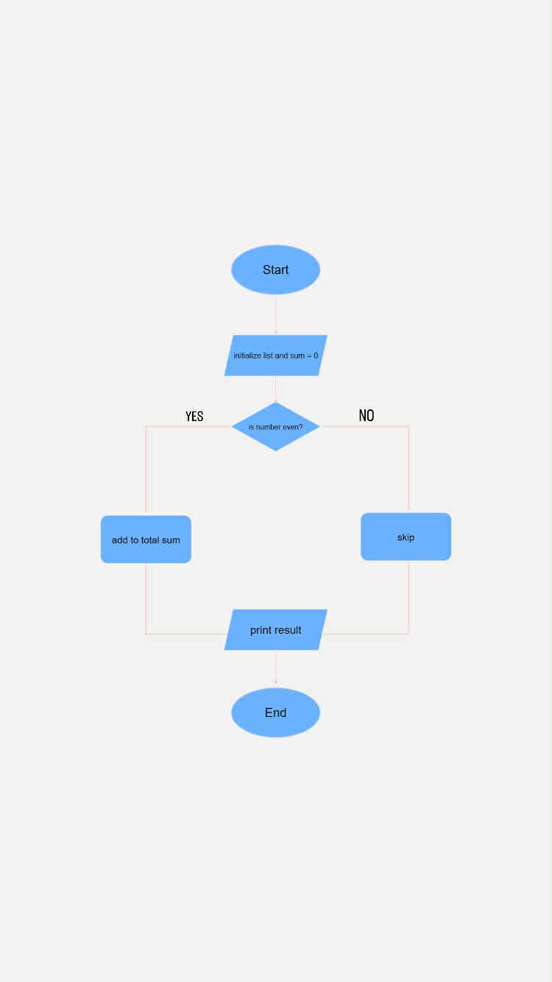

Figure 1 Flowchart

• Translate the algorithm to a Python program (using Google Colab)

[LAB 3.ipynb - Colab](https://colab.research.google.com/drive/1vQvJtC40stMY4MxHsx2xz4R7kcGt2BaF)

# Conclusion

This laboratory activity focused on applying algorithm design and flowchart creation to solve a simple computing problem. The task involved identifying even numbers from a set of test scores and calculating their total. Through this process, the importance of organizing steps clearly and understanding program logic was emphasized. Proper use of algorithms and flowchart techniques supports efficient and accurate programming solutions.

**References**

[1] Co Arthur O.. “University of Caloocan City Computer Engineering Department Honor Code,” UCC-CpE Departmental Policies, 2020.

[2] diagrams.net, "App.diagrams.net – Online Diagram Software," https://app.diagrams.net [Accessed: Aug. 2, 2025].

[3] Google Colab, "Untitled notebook," https://colab.research.google.com/drive/16WioaYP91QkmSV73zI_4odOyUP-Usnli [Accessed: Aug. 2, 2025].